**Materials for Vision Impairment Experience Challenges**

**Contents**

Visual Impairment Goggles

Protocol for Making Vision Impairment Goggles

Template – Vision Impairment Goggles

Student worksheets – Macular Degeneration and Retinitis Pigmentosa

Visual Impairment Challenge Stations

Station 1 – Breakfast Time

Station 2 – Shopkeeper (+ printable money and price list)

Station 3 – Phone a Friend (+ printable dial-pad and business cards)

Station 4 – Sock Match-Up

Station 5 – What’s cooking good looking (+ recipe)

Station 6 - Heads

Class Data Sheets for Stations

**Protocol for Making Vision Impairment Goggles**

MATERIALS

* **Two print outs of the ‘glasses template’** – as the base for your vision impairment goggles
* **Glad wrap or transparent clear plastic -** 4 cm by 4 cm to create windows that can be marked with nail polish
* **Clear nail polish –** to make permanent changes to the surface of the glad wrap or plastic
* **1 pen**

**Vision impairment goggles ‘A’: Macular Degeneration**

* Print and cut out one glasses template. Cut out the circles in the middle of the glasses, and attach the free arm to the glasses
* Tape the glad wrap or plastic so that they cover the holes in the glasses.
* Place a thick dot of clear nail polish of approximately 1.5cm diameter in the centre of the glad wrap or plastic.
* When the nail polish has dried to the sticky stage, dab it with a tissue. (Don't let the tissue drag the polish all over the glass).

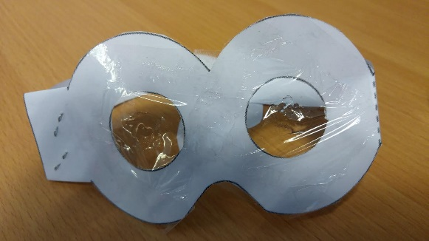

**Vision impairment goggles ‘B’: Retinitis Pigmentosa**

You will make the field loss absolute by having paper covering most of the field of view.

* Print and cut out one glasses template. DO NOT cut out the circles in the middle of the glasses. Attach the free arm to the glasses.
* Using your pen, poke a hole through the centre of the circles, and poke the pen the whole way through so that you have a very small circular hole for the left and right eye.

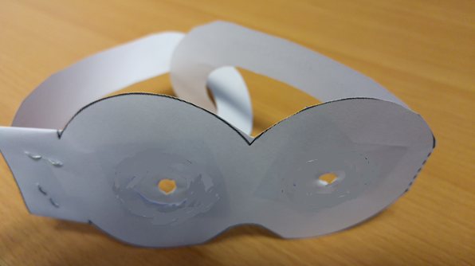

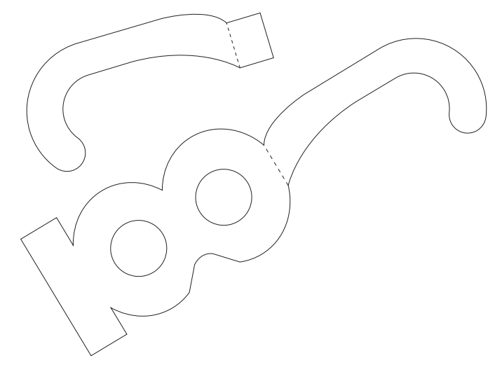

|  |  |
| --- | --- |
| **Age Related Macular Degeneration**  The most common form of vision impairment that results in blindness is **age-related macular degeneration**. In people who are affected, vision progressively gets worse over time.  There is a part in the back of your eye called the **macula** which is responsible for your central, detailed vision. Damage to this region causes damage to these aspects of your vision. This can affect an individual’s ability to see fine detail, drive and recognise faces.    **Figure 1 – An example of the effect of Macular Degeneration on how a street scene is perceived.** Over timemacular degeneration causes irreversible central vision loss. Image from: <http://www.clellandandboyd.com/communities/3/004/012/343/113//images/4604134836.jpg>, accessed 29th April 2016. | **Retinitis Pigmentosa**  Retinitis pigmentosa refers to a group of genetically inherited conditions that causes progressive vision loss. Retinitis pigmentosa leads to an irreversible loss of peripheral vision over time. Your peripheral vision gives you the ability to see general shapes and gives you a 'get-about‘ sense when you are moving about.  In these disorders there are abnormalities in the cells in the eye that normally detect light, and send signals to your brain. These abnormalities lead to progressive loss of vision. People affected with these conditions first experience difficulty seeing in low light conditions, and develop “night blindness”. Following this, they experience reduced peripheral vision. Eventually, they can lose central vision as the disease progresses to its late stages.  **Figure 2 – An example of the effect of Retinitis Pigmentosa on how a street scene is perceived.** Over timeRetinitis Pigmentosa changes the area that is available to receive information from the world. As this area gets smaller, the amount of information that is perceived from the eye gets smaller, resulting in a reduced field of view. Image retrieved from: <http://li129-107.members.linode.com/about-low-vision-blindness/vision-disorders/retinitis-pigmentosa/>, last accessed 29th April 2016. |

**Student cards – Macular Degeneration and Retinitis Pigmentosa**

|  |  |
| --- | --- |
| Station 1 – **Breakfast time** (Choosing food for breakfast)  The aim of this challenge is to correctly identify and choose three specific cans with and without wearing visual impairment (VI) goggles.  Materials:   * Various cans (beans, corns, tomatoes etc.) * VI goggles (2 types) * Shelf * Timer   Method:   * Student 1 arranges cans on the shelf and requests three separate cans which Student 2 should pick up, one after another. * Without the vision impairment goggles, Student 2 identifies which cans to pick and takes them from the shelf while Student 1 times them. * Repeat with both pairs of VI goggles and record times. * Student 1 and Student 2 swap roles and repeat. | Record your times taken to complete the task for each member of your pair to the station data sheet.  After you have completed the task without goggles, with the Macular Degeneration goggles and the Retinitis Pigmentosa goggles, discuss these questions in your pairs:  *Q1. What difficulties did you encounter during the task while wearing the Macular Degeneration and Retinitis Pigmentosa goggles?*  *Q2. How would you compensate for your difficulties in this task if you had Retinitis Pigmentosa/Macular Degeneration?*  *Q3. Did you use any other senses to compensate for your loss of vision during this task? Which senses did you use and how did you use them?* |
| Station 2 – **Shopkeeper**  The aim of this challenge is to give correct amount of change to your customer in the shortest amount of time with and without wearing visual impairment (VI) goggles.  Materials:   * VI goggles (2 types) * Items for sale * Price list * Timer * A range of coins and notes   Method:   * Items are arranged on a desk and Student 1 is the customer. * Student 2 first completes the task without VI goggles and listens to the customer order. * Student 2 calculates the total amount for the item(s). * Student 2 counts out the amount of money to give while Student 1 times them. * Repeat with the first pair of VI goggles, then with the other. * Student 1 and Student 2 swap roles and repeat. | Record your times taken to complete the task for each member of your pair to the station data sheet.  After you have completed the task without goggles, with the Macular Degeneration goggles and the Retinitis Pigmentosa goggles, discuss these questions in your pairs:  *Q1. What difficulties did you encounter during the task while wearing the Macular Degeneration and Retinitis Pigmentosa goggles?*  *Q2. How would you compensate for your difficulties in this task if you had Retinitis Pigmentosa/Macular Degeneration?*  *Q3. Did you use any other senses to compensate for your loss of vision during this task? Which senses did you use and how did you use them?* |

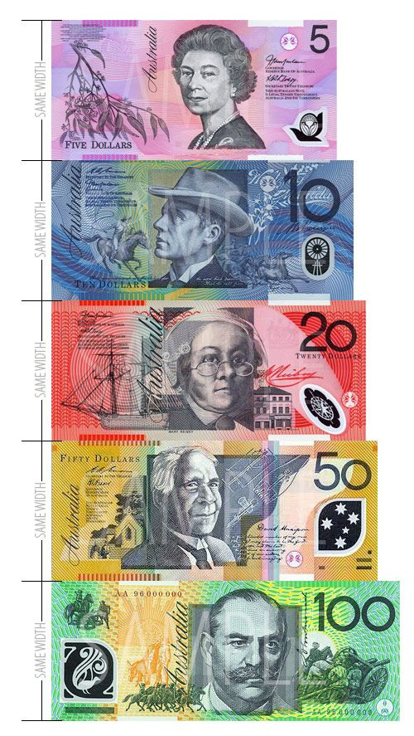

CANTEEN PRICE LIST - 2016

**SANDWICHES**

Vegemite $3.00  
Cheese $3.00  
Ham $3.00  
Cheese & Salad $6.00   
Ham & Salad $6.50

**WRAPS**

Salad $6.50  
Chicken & Salad $7.50

**HOT FOOD**

Meat Pie $4.60  
Sausage Roll $3.60  
Pasty $4.00

**CAKES**Muffins $3.90  
Finger Buns $2.70

**DRINKS**Drinks 600ml $4.20  
Flavoured Milk 375ml $3.30  
Flavoured Milk 600ml $4.30  
Juice $2.60

|  |  |
| --- | --- |
| Station 3 – **Phone a friend** (Dialing a phone number)  The aim of this activity is to correctly dial a phone number with and without wearing visual impairment (VI) goggles.  Materials:   * A mobile telephone or photocopy of a telephone dial pad * A pile of business cards with phone numbers * VI goggles (2 types)   Method:   * Student 1 selects a business card from the pile and dials without VI goggles – Student 2 times them. * Student 1 wears VI goggles, selects a second business card and dials the phone number – Student 2 times them. * Student 1 repeats the activity wearing the second pair of VI goggles. * Student 1 and Student 2 swap roles and repeat | Record your times taken to complete the task for each member of your pair to the station data sheet.  After you have completed the task without goggles, with the Macular Degeneration goggles and the Retinitis Pigmentosa goggles, discuss these questions in your pairs:  *Q1. What difficulties did you encounter during the task while wearing the Macular Degeneration and Retinitis Pigmentosa goggles?*  *Q2. How would you compensate for your difficulties in this task if you had Retinitis Pigmentosa/Macular Degeneration?*  *Q3. Did you use any other senses to compensate for your loss of vision during this task? Which senses did you use and how did you use them?* |

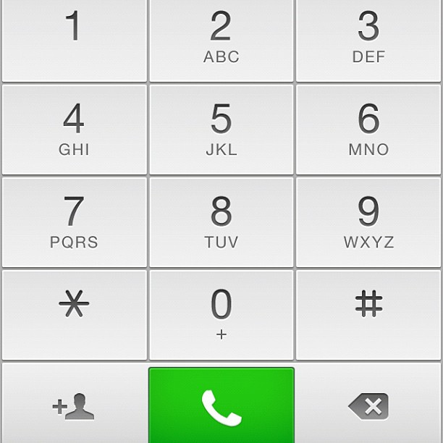

Above image is: [“New #ios6 dial pad design”](https://www.flickr.com/photos/yakobusan/7369337684) by [Jakob Montrasio](https://www.flickr.com/photos/yakobusan/7369337684) is licensed under [CC BY 2.0](https://creativecommons.org/licenses/by/2.0/)

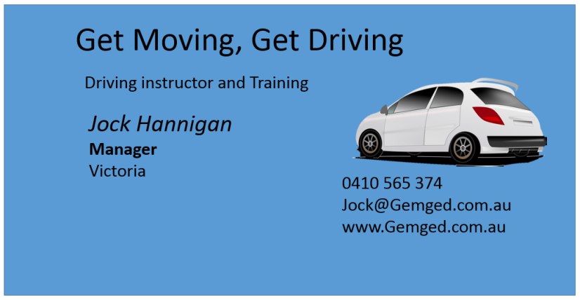 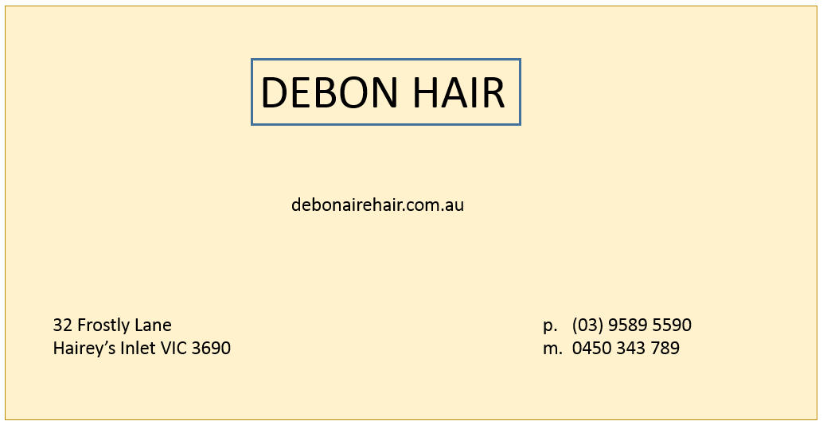 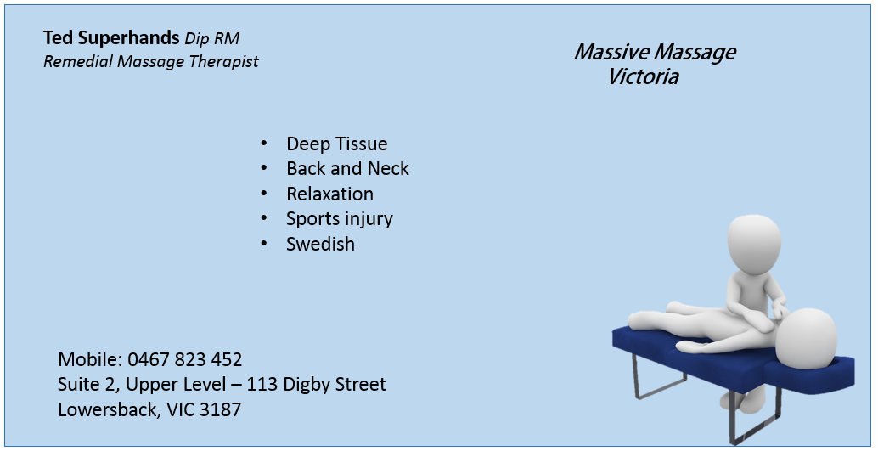  

|  |  |
| --- | --- |
| Station 4 - **Sock match-up**  The aim of this activity is sort socks into correct pairs with and without wearing visual impairment (VI) goggles within the shortest period of time.  Materials:   * Timer * 8 pairs of socks * VI goggles (2 types)   Method:   * Socks are piled on the desk. * Student 1 wears no goggles and completes the activity * Student 1 then completes the activity with the first and second pair of VI goggles. * Student 2 records the time and how many times Student 1 attempted this activity incorrectly under each condition. | Record your times taken to complete the task for each member of your pair to the station data sheet.  After you have completed the task without goggles, with the Macular Degeneration goggles and the Retinitis Pigmentosa goggles, discuss these questions in your pairs:  *Q1. What difficulties did you encounter during the task while wearing the Macular Degeneration and Retinitis Pigmentosa goggles?*  *Q2. How would you compensate for your difficulties in this task if you had Retinitis Pigmentosa/Macular Degeneration?*  *Q3. Did you use any other senses to compensate for your loss of vision during this task? Which senses did you use and how did you use them?* |

|  |  |
| --- | --- |
| Station 5 – **What’s cooking, good looking?** (Reading a recipe)  The aim of this activity is to read steps of the method of short recipe with and without wearing the visual impairment (VI) goggles in the shortest amount of time.  Materials:   * VI goggles (2 types) * Recipe * Timer   Method:   * Student 1 reads the first two steps of the recipe’s method without VI goggles while Student 2 records the time taken. * Repeat experiment with one pair of VI goggles (but read the third and fourth steps) and with the second pair of VI goggles (and read the fifth and sixth steps).   Student 1 and Student 2 swap roles and repeat, and record the time taken to complete the reading under each condition. | Record your times taken to complete the task for each member of your pair to the station data sheet.  After you have completed the task without goggles, with the Macular Degeneration goggles and the Retinitis Pigmentosa goggles, discuss these questions in your pairs:  *Q1. What difficulties did you encounter during the task while wearing the Macular Degeneration and Retinitis Pigmentosa goggles?*  *Q2. How would you compensate for your difficulties in this task if you had Retinitis Pigmentosa/Macular Degeneration?*  *Q3. Did you use any other senses to compensate for your loss of vision during this task? Which senses did you use and how did you use them?* |

Banana Bread Recipe

**Ingredients**

Melted butter, to grease

1 ¾ cups self-raising flour

¼ cup plain flour

1 tsp plain cinnamon

2/3 cup brown sugar

½ cup milk

2 eggs, lightly whisked

50 grams butter, melted

2 overripe bananas, mashed

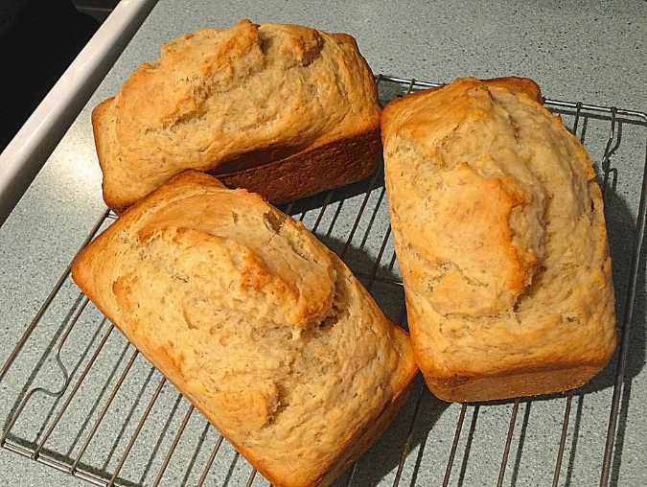

**Method**

Pre-heat oven to 180C. Brush an 11x21cm loaf pan with melted butter to lightly grease. Line the tin with baking paper.

Sift the flours and cinnamon into a large bowl. Stir in the sugar and make a well in the centre. Place the eggs, milk, banana and melted butter into a separate bowl, and stir until they are combined.

Add the banana mixture to the flour mixture and stir until combined. Spoon the mixture into your loaf pan.

Bake in a pre-heated over for 40-50 minutes. Remove from oven and cool on a wire rack. Serve cut into slices with butter.

|  |  |
| --- | --- |
| Station 6 – **Heads!** (Catching a ball)  The aim of this challenge is to test coordination by throwing and receiving a tennis ball by recording time it takes to successfully catch a ball five times with and without wearing visual impairment (VI) goggles.  Materials:   * VI goggles (2 types) * Tennis ball   Method:   * Student 2 throws a tennis ball to Student 1 five times (control round). * Student 2 repeats the activity while Student 1 wears the VI goggles while trying to catch the ball. * Repeat with the other pair of VI goggles. * Students record time taken to catch the ball five times successfully for both normal vision and VI goggles. | Record your times taken to complete the task for each member of your pair to the station data sheet.  After you have completed the task without goggles, with the Macular Degeneration goggles and the Retinitis Pigmentosa goggles, discuss these questions in your pairs:  *Q1. What difficulties did you encounter during the task while wearing the Macular Degeneration and Retinitis Pigmentosa goggles?*  *Q2. How would you compensate for your difficulties in this task if you had Retinitis Pigmentosa/Macular Degeneration?*  *Q3. Did you use any other senses to compensate for your loss of vision during this task? Which senses did you use and how did you use them?* |

**Station 1: Choosing Food for Breakfast - Time taken to complete challenge with and without vision impairment goggles**

|  |  |  |  |
| --- | --- | --- | --- |
|  | **Control** (No goggles) | **Macular Degeneration** | **Retinitis Pigmentosa** |
| **CLASS DATA:**  Time taken to  complete  challenge (seconds) |  |  |  |
| **ORDERED TIMES** |  |  |  |
| **5 NUMBER SUMMARY** |  |  |  |
| Box plots  CONTROL  MACULAR DEGENERATION  RETINITIS PIGMENTOSA | http://blog.aimsedu.org/wp-content/uploads/2014/02/Paper-Number-Line.jpg | | |

**Station 2: Choosing Correct Change - Time taken to complete challenge with and without vision impairment goggles**

|  |  |  |  |
| --- | --- | --- | --- |
|  | **Control** (No goggles) | **Macular Degeneration** | **Retinitis Pigmentosa** |
| **CLASS DATA:**  Time taken to  complete  challenge (seconds) |  |  |  |
| **ORDERED TIMES** |  |  |  |
| **5 NUMBER SUMMARY** |  |  |  |
| Box plots  CONTROL  MACULAR DEGENERATION  RETINITIS PIGMENTOSA | http://blog.aimsedu.org/wp-content/uploads/2014/02/Paper-Number-Line.jpg | | |

**Station 3: Dialling a Phone Number: Time taken to complete challenge with and without vision impairment goggles**

|  |  |  |  |
| --- | --- | --- | --- |
|  | **Control** (No goggles) | **Macular Degeneration** | **Retinitis Pigmentosa** |
| **CLASS DATA:**  Time taken to  complete  challenge (seconds) |  |  |  |
| **ORDERED TIMES** |  |  |  |
| **5 NUMBER SUMMARY** |  |  |  |
| Box plots  CONTROL  MACULAR DEGENERATION  RETINITIS PIGMENTOSA | http://blog.aimsedu.org/wp-content/uploads/2014/02/Paper-Number-Line.jpg | | |

**Station 4: Sock Match-Up - Time taken to complete challenge with and without vision impairment goggles**

|  |  |  |  |
| --- | --- | --- | --- |
|  | **Control** (No goggles) | **Macular Degeneration** | **Retinitis Pigmentosa** |
| **CLASS DATA:**  Time taken to  complete  challenge (seconds) |  |  |  |
| **ORDERED TIMES** |  |  |  |
| **5 NUMBER SUMMARY** |  |  |  |
| Box plots  CONTROL  MACULAR DEGENERATION  RETINITIS PIGMENTOSA | http://blog.aimsedu.org/wp-content/uploads/2014/02/Paper-Number-Line.jpg | | |

**Station 5: Reading a Recipe - Time taken to complete challenge with and without vision impairment goggles**

|  |  |  |  |
| --- | --- | --- | --- |
|  | **Control** (No goggles) | **Macular Degeneration** | **Retinitis Pigmentosa** |
| **CLASS DATA:**  Time taken to  complete  challenge (seconds) |  |  |  |
| **ORDERED TIMES** |  |  |  |
| **5 NUMBER SUMMARY** |  |  |  |
| Box plots  CONTROL  MACULAR DEGENERATION  RETINITIS PIGMENTOSA | http://blog.aimsedu.org/wp-content/uploads/2014/02/Paper-Number-Line.jpg | | |

**Station 6: Catching a Ball - Time taken to complete challenge with and without vision impairment goggles**

|  |  |  |  |
| --- | --- | --- | --- |
|  | **Control** (No goggles) | **Macular Degeneration** | **Retinitis Pigmentosa** |
| **CLASS DATA:**  Time taken to  complete  challenge (seconds) |  |  |  |
| **ORDERED TIMES** |  |  |  |
| **5 NUMBER SUMMARY** |  |  |  |
| Box plots  CONTROL  MACULAR DEGENERATION  RETINITIS PIGMENTOSA | http://blog.aimsedu.org/wp-content/uploads/2014/02/Paper-Number-Line.jpg | | |